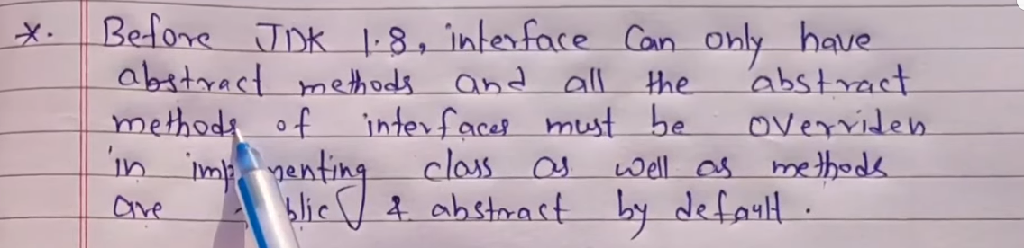

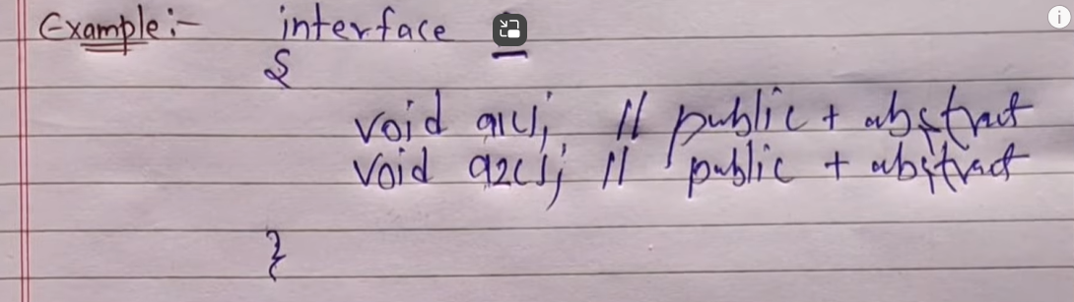

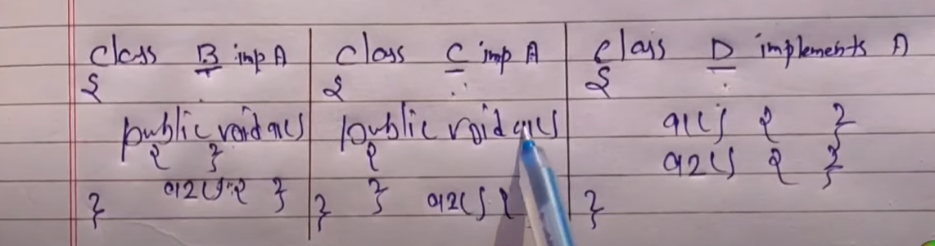



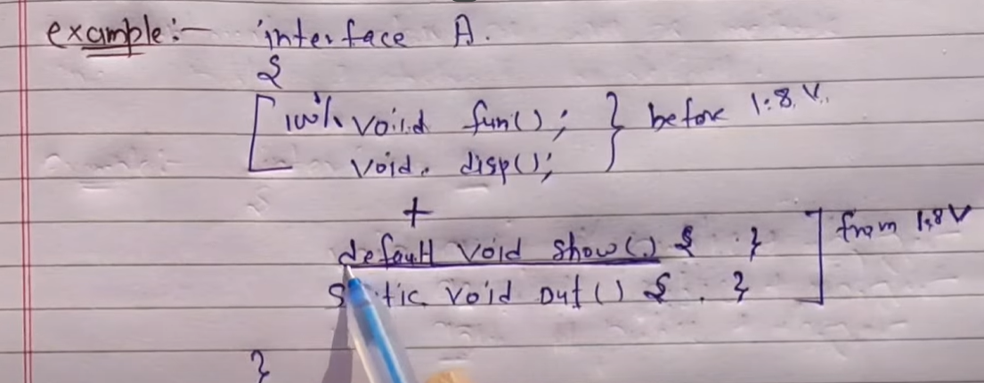

Now we can create default , static methods in interface and can implement inside method. Not necessary override in sub classess

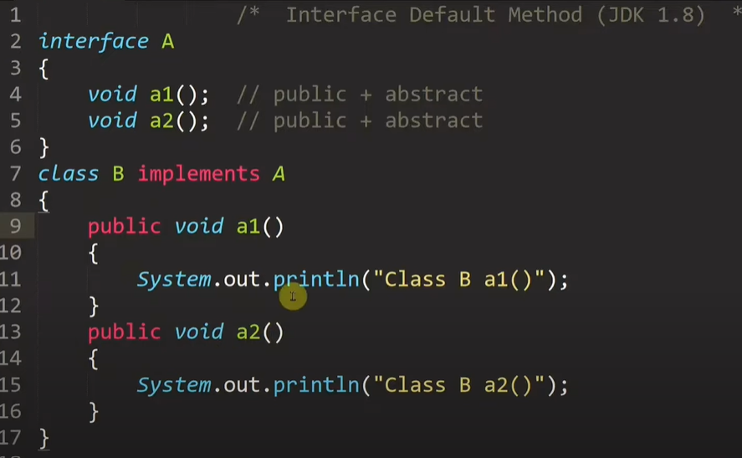

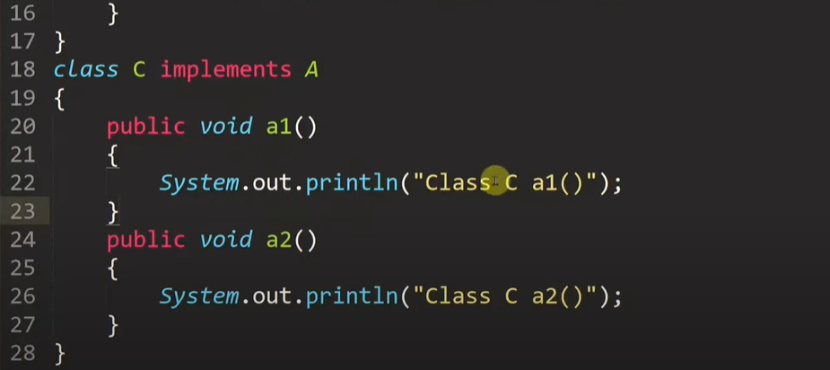

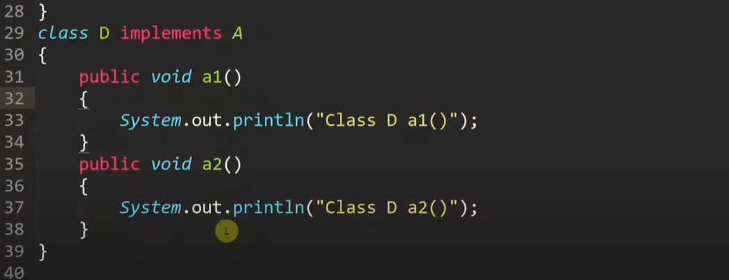

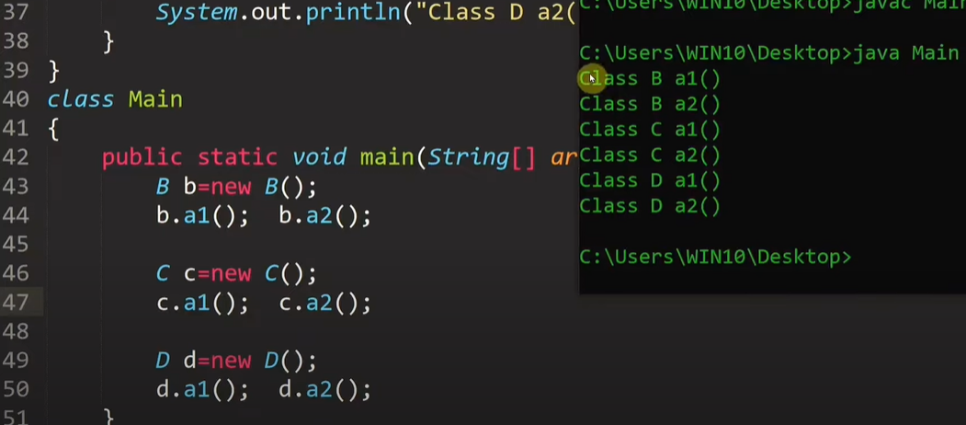

Now adding new method to a3 in interface . earlier b , c and d need to implements method a3 otherwise they will become abstract.

Previously we can say that interface was 100% abstract but after introduction default and static methods it is not 100% abstract

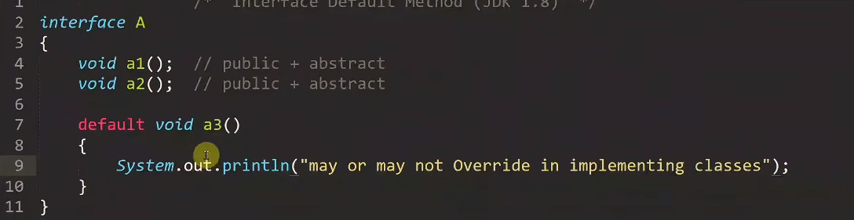



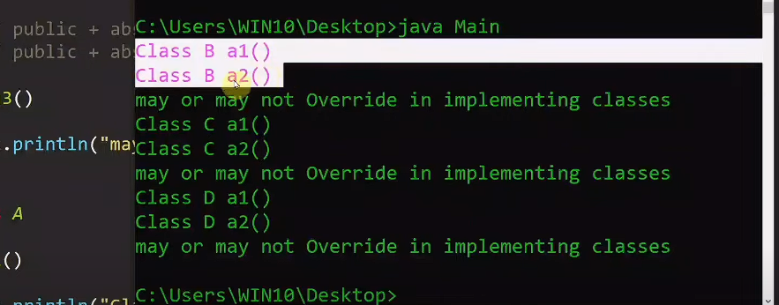

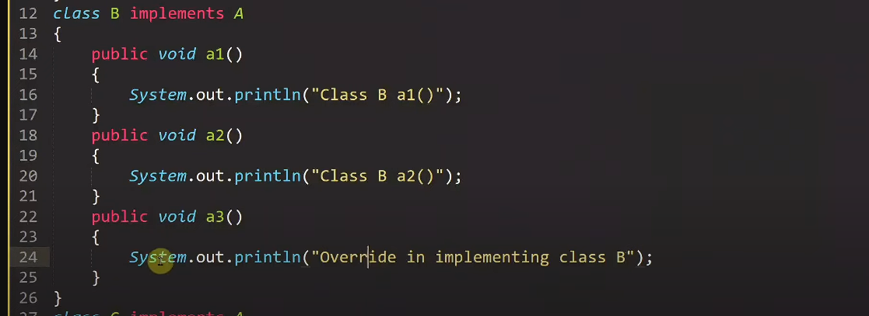



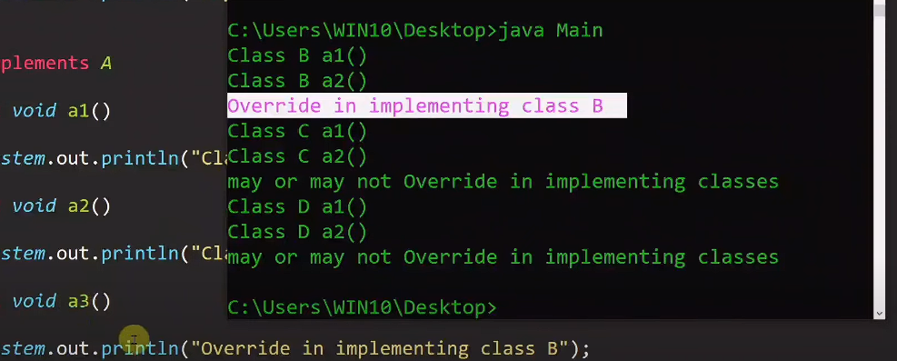

Static method was introduced in interface because we dindt need to create obj to access static method

Static methos in interface can be only implemented inside the interface. It cant be overide.

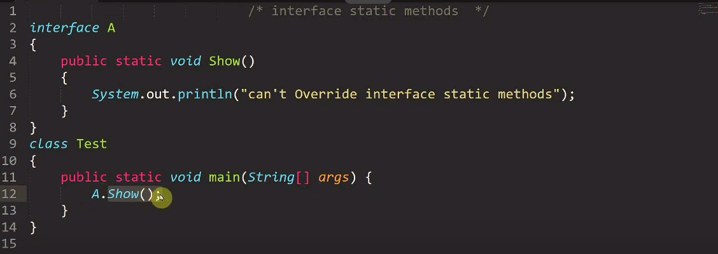

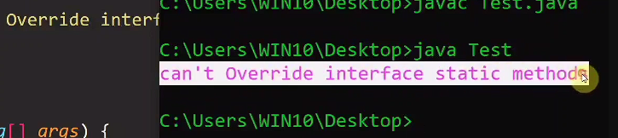

Inside interface we can have main method as it is static

